Lifelong Long-Acting Injectable ARV Protocol
Adapted from Ward 86 Long-Acting Injectable ARV Protocol

Background
CABENUVA is an injectable prescription medicine to treat HIV-1 infection in adults. Cabenuva contains two different medications: cabotegravir, an integrase strand transfer inhibitor (INSTI) and rilpivirine, a non-nucleoside reverse transcriptase inhibitor (NNRTI). CABENUVA is administered as intramuscular (IM) gluteal injection only and must be administered by a licensed health care professional. Per FDA labeling, CABENUVA may be started with an oral lead in to assess tolerability or it may be started direct-to-inject.

Recommended Dosing
Cabenuva is approved for every 4-week and every 8-week dosing. The recommended loading and maintenance dosing vary as follows:

Optional Oral Lead In x 28 days
Cabotegravir 30mg once daily with a meal
Rilpivirine 25 mg once daily with a meal

Every 4 Week Intramuscular Injection Dosing Schedule in Adults
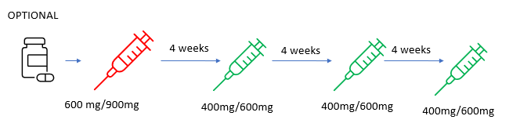
* Maintenance doses may be given up to 7 days early or late

Every 8 Week Intramuscular Injection Dosing Schedule in Adults
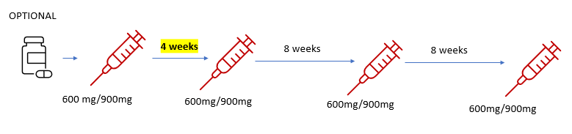
* Maintenance doses may be given up to 7 days early or late

Other administration considerations: Use a 2 inch needle for BMI≥30 kg/m²

Eligibility Criteria
- Patient expresses willingness and demonstrates ability to attend monthly to every other month appointments to receive injections (two injections in gluteal muscle)
- Patient has a reliable phone number(s) and/or active MyChart, and ideally provides, at minimum, two other methods of contacts (family members, friends, case manager, etc)
- Patients who have been HIV virologically suppressed for the last 6 months (HIV RNA <50 c/mL) are preferred
- Patients with CrCl <30mL/min are acceptable, patients should be monitored closely for adverse effects
- Patients who are pregnant or breastfeeding are not eligible
- Patients do not have history of known or suspected drug resistance that would compromise this regimen.
  - Rilpivirine: L100I; K101E; V106I and A; V108I; E138K and A, G, Q, R; V179F and I; Y181C and I; V189I; G190E; H221Y and H/L; F227C; and M230I and L; K103N+K238T, K103N+E138G+K238T; Y188L
  - Cabotegravir: Q146L; S153Y; I162M; T124A; Q148H, K; C56S; V72I; L74M; V75A; T122N; E138K; G140S; G149A; M154I; and N155H
- Patients do not have prior hypersensitivity to cabotegravir or rilpivirine
- Patients who are on the following medications are not eligible (due to concern of decreased drug levels of CAB or RPV)
- Anticonvulsants: carbamazepine, oxcarbazepine, phenobarbital, phenytoin
- Antimycobacterials: rifabutin, rifampin, rifapentine
- Systemic glucocorticoids: more than a single dose of dexamethasone
- Herbal: St John’s Wort
- For oral lead in only: PPI’s (H2 blockers allowable if dosed 12 hours before or 4 hours after rilpivirine)

Patient Education
- See attached flyer

Process for Referral and Initiation
Provider:
- Use .sa185cabenuvastartchecklist (.cabstart) smartphrase to ensure you are reviewing and ordering all needed items.
- Ensure patient has a 30-day supply of alternative oral regimen (can be prior regimen)
- Notify identified case manager of plan to start CABENUVA and if using oral lead in order from Theracom with delivery to office or patient home as preferred.
- Order loading and maintenance doses for delivery to clinic from AHF pharmacy or Walgreen’s community pharmacy.
- Notify MAC and RN’s of medication order and plan to ensure medications are refrigerated immediately upon delivery.
- Order Cabenuva on MAR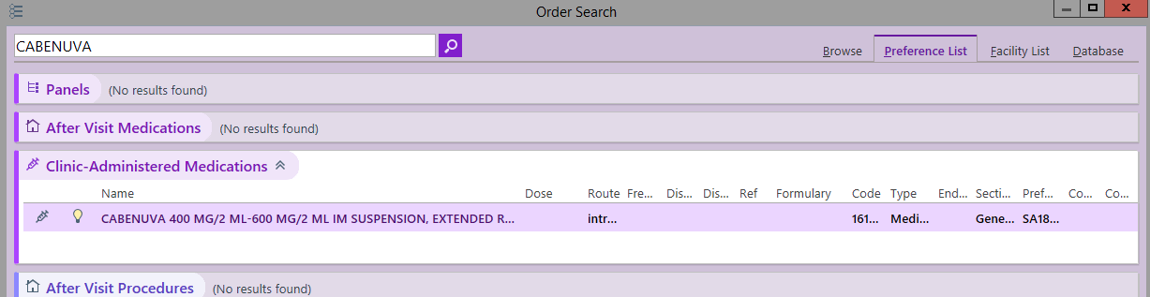

Case Manager:
- Ensure we have 2 alternate contacts for patient on file (with signed authorization to release form)
- Follow-up with pharmacies to ensure delivery of medication and will facilitate RN appointment for injection.
- Maintains a log of patients who are on CABENUVA, ensures that future appointments and labs are scheduled appropriately, and conducts reminder calls to patients for all CABENUVA related visits
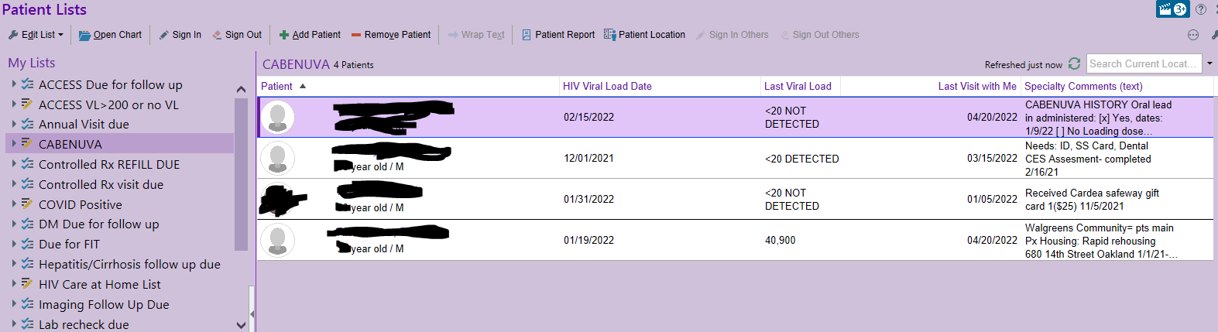
- Fills out .sa185cabenuvahx under specialty notes
- 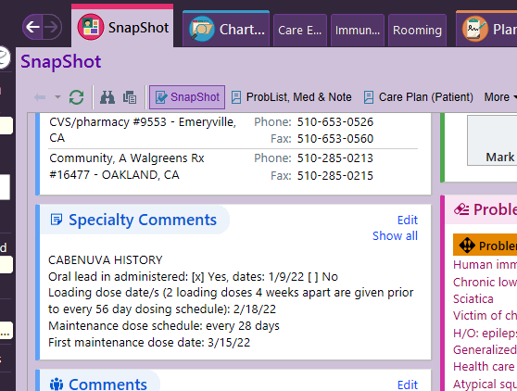

Oral Treatment Follow Up
- Telephone visit scheduled within a week post start of oral lead-in to assess adherence and tolerability
- If intolerant or non-adherent to oral lead-in treatment, CABENUVA injections will not be scheduled
- If patient tolerates oral lead-in and demonstrates adherence to regimen:
  - CABENUVA 600/900mg initiation prescription is sent to pharmacy and ordered as clinic administered medication
  - Case manager facilitates RN appointment for injection
    - Patient will also have labs drawn on day of initiation injection
      - HIV VL, CMP, CBC
Initial Injection Follow Up
  - Telephone visit is scheduled within seven days of patient receiving initiation injection to assess for tolerability
  - If patient tolerates treatment:
    - CABENUVA 400/600mg OR 600/900mg maintenance prescription is sent to pharmacy and ordered as clinic administered medication
    - Case manager schedules future RN appointments on a 28 day or 56 day CYCLE as indicated
- Patient will have the following labs repeated at first maintenance injection (28 days after initiation injection):
  - HIV VL, CMP
    - Patients may be given CABENUVA up to seven days before or after the date the patient is scheduled to receive monthly injections

Monitoring on Maintenance Injections
- Once patients have completed initiation injection, and first maintenance injection and corresponding lab work, HIV VL is to be monitored at a minimum of every three months (i.e. during every third maintenance injection appointment). Change to every 2-4 months if they can get labs on day of Injection
- Primary care provider will assess patient one month after first injection and at minimum every three months for six months following initiation

Storage, Handling, and Administration
- See attached handout

Response to Missed Injection
Unplanned
If a patient misses a scheduled injection, Case Manager will reach out to patient and if not able to reach patient by end of business day, Case Manager will call patient’s listed contacts in Epic. If unable to reach patient or contacts, pharm tech will alert PCP and panel team via telephone encounter marked urgent.
If monthly injections are missed or delayed by more than seven days and oral therapy has not been taken in the interim, PCP needs to clinically reassess the patient to determine if resumption of injection dosing remains appropriate. Appropriate fully suppressive oral antiretroviral regimen should be started as soon as possible.
Planned
If a patient plans to miss a scheduled injection visit by more than seven days, pharmacy staff will ensure that patient is provided with daily oral therapy to replace up to two consecutive monthly injection visits.
- The recommended oral daily dose is one 30-mg tablet of Vocabria (cabotegravir) and one 25-mg tablet of Edurant (rilpivirine) with a meal
  - If Vocabria is not available, patient may be switched to Juluca (dolutegravir 50mg/rilpivirine 25mg) to be taken one tablet daily with a meal or
  - In less stable patients without access to food three drug regimen is also appropriate
- The first dose of oral therapy should be taken approximately one month after the last injection dose of CABENUVA and continued until the day injection dosing is restarted
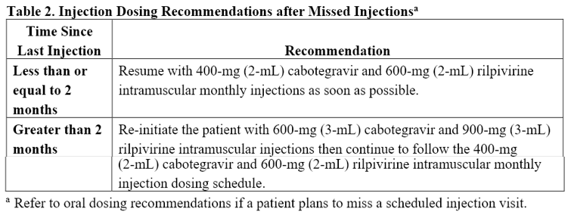
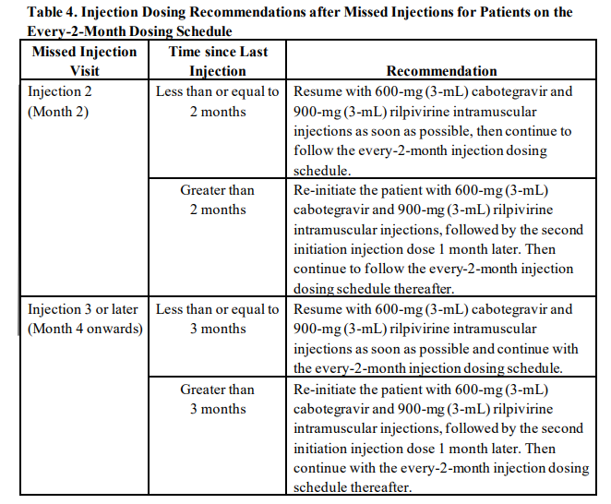
If treatment interruption is greater than 60 days (two months), patient requires re-evaluation by PCP regarding appropriateness for continued treatment.
Document/Tracking
- Documentation will be conducted in Epic using developed smartphrases
- Maintain CABENUVA Patient List in Epic for monitoring and management
Transferring Off Injections
If patient is to stop CABENUVA injections an alternative, fully suppressive antiretroviral regimen, must be prescribed by PCP. Patient needs to start oral regimen no later than 30 days following last CABENUVA injection.
Once a month, pharmacy team and leadership will assess patients on injectable therapy to continuously monitor for virologic failures and adverse effects.

To-Do:
Create standing order to highlight what provider, CM, and RN roles are

