LifeLong CAB LA Smart Phrase List

CABENUVA HISTORY
Oral lead in administered: Yes, dates: No
Loading dose date/s (2 loading doses 4 weeks apart are given prior to every 56 day dosing schedule): ***
Maintenance dose schedule: {:58033}
First maintenance dose date:
=
Cabenuva Start Checklist:

Patient History:
Prior antiretroviral treatment history reviewed
Genotype reviewed
Copy and paste below or document in problem list
Enter Stanford Database (https://hivdb.stanford.edu/hivdb/by-mutations/) to evaluate for major mutations that may preclude CABENUVA
Hepatitis B serologies reviewed
If isolated cAb positive, HBV DNA ordered to check for occult HBV infection Yes N/a
Medications reviewed for ddi's (see resources below)

Ordering/scheduling
BMI reviewed and 2-inch needles ordered for BMI >/= 30
30-day supply alternate oral regimen dispensed
Optional: Oral lead ordered
- E-scribe to Theracom 345 International Blvd Ste 200, Brooks, KY 40109 Phone: 1-844-276-6299, Fax: 1-833-904-1881
- Notes section must include the following:
  - Opt out of VC services, oral lead in only
  - Delivery location w/address (Patient home or clinic)
  - Best contact number for Theracom to call if Rx issues arise
Loading and Maintenance injections ordered
Order for clinic delivery from Walgreen's Community or AHF
For Q4 week injections order: Loading dose CAB/RPV 600-900 + Maintenance dose CAB RPV 400-600
For Q8 week injections order: CAB/RPV 600-900 to be given every 4 weeks x 2 and then every 8 weeks
RN and MAC notified of order so medications can be refrigerated upon receipt

Monitoring:
Sa185cabenuvahx smartphrase added to specialty comments
Patient added to Cabenuva patient list

Resources:
1. Cabotegravir and Rilpvirine Mutations
- Rilpivirine: L100I (H); K101E (I); V106I and A (potential L); E138K (I) and A (L), G (L), Q (L), R (L); V179F and I (L); Y181C (I) and I (H); V189I; G190E (H); H221Y (L) and H/L; F227C (I); and M230I (I) and L; K103N+K238T, K103N+E138G+K238T; Y188L
- Cabotegravir: Q146L; S153Y; I162M; T124A; Q148H, K; C56S; V72I; L74M; V75A; T122N; E138K; G140S; G149A; M154I; and N155H

2.CABENUVA Drug interactions
Patients who are on the following medications are not eligible (due to concern of decreased drug levels of CAB or RPV)
- Anticonvulsants: carbamazepine, oxcarbazepine, phenobarbital, phenytoin
- Antimycobacterials: rifabutin, rifampin, rifapentine
- Systemic glucocorticoids: more than a single dose of dexamethasone
- Herbal: St John’s Wort
- For oral lead in only: PPI’s (H2 blockers allowable if dosed 12 hours before or 4 hours after rilpivirine)

APRETUDE HISTORY
Oral lead in administered: Yes, dates: No
Loading dose date/s (2 loading doses 4 weeks apart are given prior to every 56 day dosing schedule): ***
First maintenance dose date:
Apretude Initiation Checklist:

1) Confirm eligibility (based on CDC criteria below or clinical judgment)
anal or vaginal sex in the past 6 months AND
sexual partner with HIV (especially if the partner has an unknown or detectable viral load) OR
have not consistently used a condom OR
have been diagnosed with a sexually transmitted disease in the past 6 months
OR if injecting drugs
share injection equipment OR
have injection partner with HIV

2) Evaluate HIV Status
NONE of the following symptoms today or in the past 30 days:
- fever with sore throat
- rash
- swollen lymph nodes
- Headache
*if any of the above symptoms, order HIV RNA Viral Load + 4th gen HIV Ag/Ab to rule out acute HIV before offering PrEP.
Have you used any PrEP/PEP pills in the past 3 months or injections in the past 12 months?
If YES:
order HIV RNA Viral Load + 4th gen HIV Ag/Ab; consider awaiting results before prescribing PrEP if patient reports gaps in PrEP or inconsistent use
If NO:
HIV RNA Viral Load negative result must be documented within 1 week prior to initiation of CAB-LA OR
perform a Rapid HIV Ag/Ab fingerstick to document negative status AND obtain blood draw for HIV RNA Viral Load on the same-day to confirm status (ok to administer CAB-LA while lab test is pending).
*Oral fluid HIV tests should be avoided, as they are less sensitive for the detection of acute/recent HIV infection.

3) Medications reviewed for drug interactions (see resources below)

4) Counseling
Injection site reactions (pain, tenderness, induration) were most frequent after the first 2-3 injections. These were generally mild to moderate, lasting only a few days, and improved with supportive management.
- To minimize injection site reactions, patients can take an over-the-counter pain medication within 2 hours before or after the injection and continue as needed for 1-2 days, and/or apply a warm compress or heating pad to the injection site for 15-20 minutes after the injection.
Need to monitor CAB-LA tail with HIV RNA testing every 3 months for 1 year after discontinuation
- CAB-LA levels slowly wane over an average of 10-18 months after injections are discontinued. During this “tail” phase, CAB-LA levels eventually fall below a protective threshold and persist at nonprotective levels, exposing the patient to the risk of HIV acquisition. These lower levels of CAB-LA may also create resistance to CAB or other INSTI medications if HIV is acquired during this time. Infection with INSTI-resistant virus may complicate HIV treatment.
Confirm contact information (best phone number and emergency contact)

5) Medication and Lab Orders
Loading and Maintenance injections ordered
Order for clinic delivery from Walgreen's Community or AHF
Loading dose: 3 ml suspension of 600 mg IM injected into gluteal muscle at initiation
Maintenance dose: 3 ml suspension of 600 mg IM injected into gluteal muscle 4 weeks after initiation injection, then every 8 weeks
RN and MAC notified of order so medications can be refrigerated upon receipt
4th gen HIV Ag/Ab
HIV RNA viral load qualitative or quantitative ok
STI testing: syphilis serology (RPR/VDRL), GC/CT at all sites of exposure, hepatitis C Ab
Urine pregnancy test (UPT) for patients who can become pregnant – encourage continued use of PrEP to prevent HIV transmission throughout pregnancy if UPT positive and patient has ongoing risk of acquiring HIV

6) Monitoring:
Patient added to Apretude patient list
Lab testing per chart below

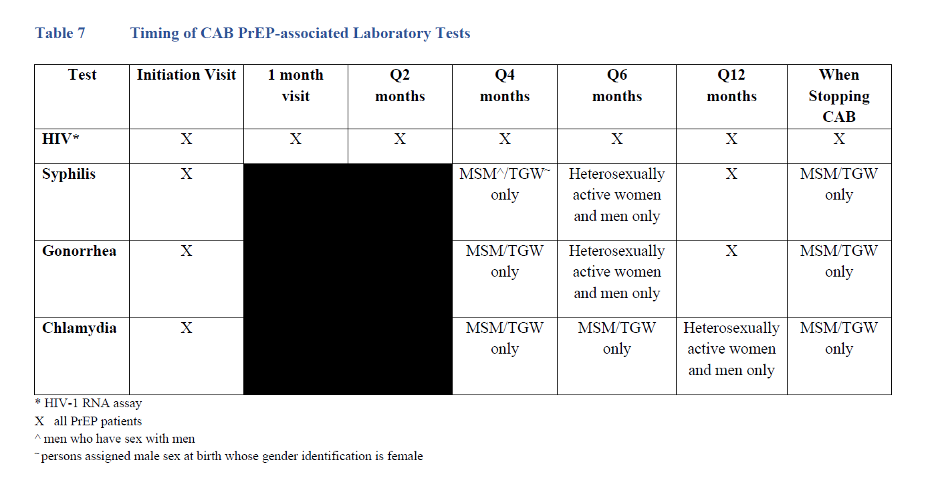
APRETUDE (CAB-LA) Drug interactions
Patients who are on the following medications are not eligible (due to concern of decreased drug levels of CAB)
- Anticonvulsants: carbamazepine, oxcarbazepine, phenobarbital, phenytoin
- Antimycobacterials: rifampin, rifapentine (rifabutin ok to administer with caution)

Injectable PrEP Initiation and Follow up Protocol
 | PrEP initiation visit | Follow-up visits (every 3 months)
HIV Status | HIV-1 qualitative (or quantitative) RNA viral load + HIV Ag/Ab test | HIV-1 qualitative (or quantitative) RNA (viral load) + HIV Ag/Ab test
STI Testing | Syphilis serology for all  GC/CT at all sites of exposure | Repeat STI screen every 4 months
Prescription | Provide cabotegravir injection at initiation visit and again 1 month later | Provide cabotegravir injection every 2 months if HIV test is negative
Discontinuation |  | Prior to initiation, counsel patients about need for monitoring CAB-LA tail with HIV RNA testing every 3 months for 1 year after discontinuation.  - If PrEP is indicated, prescribe daily oral F/TDF or F/TAF beginning within 8 weeks after last injection  - Obtain HIV RNA viral load quarterly for 12 months after discontinuing injections

Injection Dosing After Missed Injection

Dose Missed | Time Since Previous Dose | Recommendation
Second Injection | ≤ 2 months | Administer dose as soon as possible, then continue every 2 month schedule
 | > 2 months | Restart initiation dosing (2 doses separated by 1 month), followed by every 2 month schedule
Third injection or after | ≤ 3 months | Administer dose as soon as possible, then continue every 2 month schedule
 | > 3 months | Restart initiation dosing (2 doses separated by 1 month), followed by every 2 month schedule

